

Student Name | Highlighted questions are relevant to 2017 U3 AOS 1
Teacher | GSL | HAL | LLE | MDI

Chemistry Unit 3

SAC 1: Task 3, Chemical analysis test

(Concepts from Chapters 2 - 7.4)

13th April 2015
Reading time: 5 minutes
Writing time: 65 minutes

Section | Number of questions | Number of questions to be answered | Number of marks
A | 13 | 13 | 13
B | 4 | 4 | 39
Total 52

- Students are permitted to bring into the examination room: pens, pencils, highlighters, erasers, sharpeners, rulers, and one scientific calculator.
- Students are not permitted to bring into the examination room: blank sheets of paper and/or white out liquid/tape.
Materials supplied
- This question and answer book of 16 pages including a multiple choice answer sheet on page 7.
- A data booklet
Instructions
- Write your name in the space provided above on this page and circle your teacher code.
- All responses must be written in English.
- Do not write on the Data Book.

Students are NOT permitted to bring mobile phones and/or any other unauthorised electronic devices into the examination room.

Students must not disclose the contents of the task; to do so will be a breach of VCE guidelines and will be dealt with according to VCAA regulations.

SECTION A: Multiple-choice questions

Instructions for Section A
Answer all questions in pencil on the answer sheet provided for multiple choice questions.
Choose the response that is correct or that best answers the question.
A correct answer scores 1, an incorrect answer scores 0.
Marks will not be deducted for incorrect answers.
No marks will be given if more than one answer is completed for any question.

Use the following information to answer questions 1 and 2
A thin layer chromatography (TLC) plate was set up with a non-polar solvent (hexane) and a polar stationary phase (silica gel). A mixture containing several compounds was run, and the chromatogram below was obtained. A ruler was then placed next to the plate.

Question 1
The Rf value for compounds 1, 2 and 3 are:
A. | 0.89, 0.56 and 0.44
B. | 0.30, 0.40 and 0.70
C. | 0.78, 0.44 and 0.33
D. | 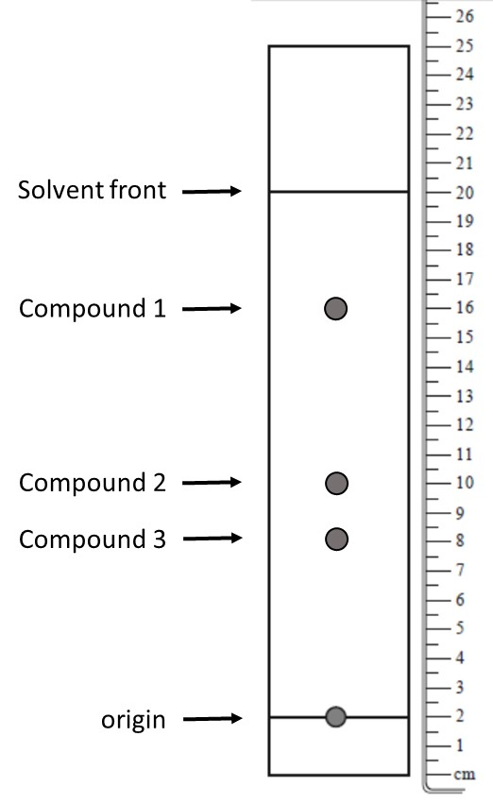  0.80, 0.50 and 0.40

Question 2
Based on the TLC results, which of the following statements is true?
A. | Compound 1 and 2 are more polar than Compound 3
B. | Compound 3 is the most polar compound
C. | Compound 2 and 3 are less polar than Compound 1
D. | Compound 2 is more polar than Compound 3

Question 3
The equivalence point for a titration of a weak acid with a strong base is most likely to be at a pH
A. | between 4 and 7
B. | between 7 and 11
C. | exactly 7
D. | below 4

Question 4
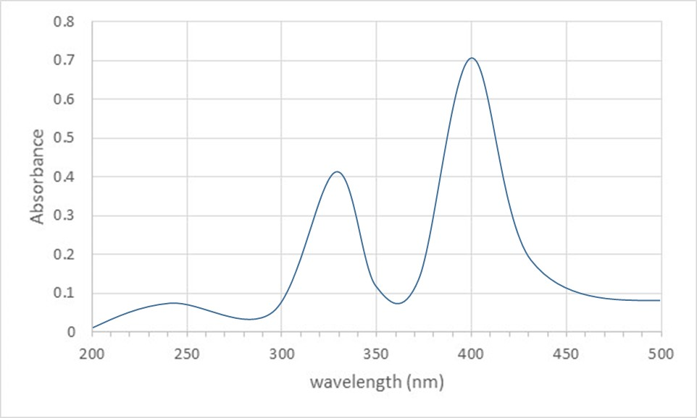
The UV-visible spectrum of a solution of a certain compound is shown above. Consider the following statements about this compound and its UV-visible spectrum.
- The spectrum is a result of electrons being excited from lower to higher energy levels.
- The amount of light absorbed by a solution of this compound does not depend on the wavelength of light used.
- The amount of light absorbed by a solution of this compound depends on its concentration.
- The concentration of a solution of this compound can only be determined by UV-visible spectroscopy at 400 nm.
Which of the above statements are true?
A. | II and III
B. | I and III
C. | I, II and III
D. | I, III and IV

Question 5
Analysis of the components of a mixture using gas-liquid chromatography normally involves
- Measuring R_{f} values of the components
- Measuring retention times of the components
- Using a liquid as the mobile phase
- Using a gas as the mobile phase
Which of the above statements are true?
A. | I and III
B. | I and IV
C. | II and III
D. | II and IV

Question 6
Chromatogram 1 was obtained by analysis of a sample of a mixture of two non-polar alkanes, A and B, using gas chromatography (GC). Chromatogram 2 was obtained by analysing another sample of the same mixture, using the same GC instrument, under different experimental conditions.
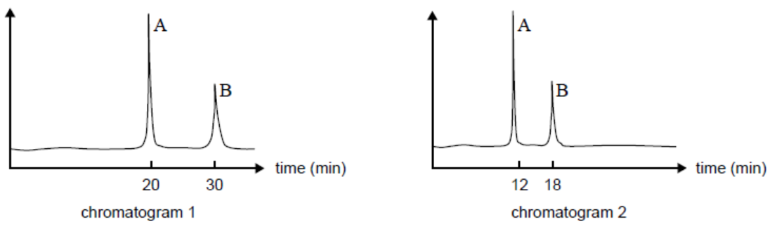
Consider the following changes that could be made to the operating conditions for GC.
- decreasing the pressure of the mobile phase
- increasing the temperature
- using a more polar column
Which of the changes would be most likely to produce chromatogram 2?
A. | I only
B. | II only
C. | I and III
D. | II and III

Question 7
An aqueous solution of nickel chloride is a clear green colour. The concentration of this solution is to be measured using UV-visible spectroscopy. An aqueous nickel chloride will
A. | absorb mainly purple light and therefore allow purple light to pass through the solution.
B. | absorb mainly purple light and therefore allow green light to pass through the solution.
C. | absorb mainly green light and therefore allow purple light to pass through the solution.
D. | absorb mainly green light and therefore allow green light to pass through the solution.

Question 8
An aqueous solution of copper sulfate appears blue in colour and its concentration can be determined by measuring its absorption at 600 nm. Which of the following errors will lead to a concentration lower than the real value:
- Rinsing the colorimeter cell with water.
- Preparing the calibration graph with a stock copper(II) sulfate solution that was 0.1 M less concentrated than what was written on the label.
- Forgetting to take into account that the solution of unknown concentration was diluted before measuring its absorbance
A. | I only
B. | I and II
C. | I and III
D. | I, II and III

Question 9
Which of the following statements is correct?
A. | The oxidation number for sulfur in CaSO₄ is +4
B. | The oxidation number for iron in Fe₂O₃ is +6
C. | The oxidation number for manganese in KMnO₄ is +1
D. | The oxidation number for sulfur in SO₃²⁻ is +4

Question 10
Which of the following shows a balanced equation for the reaction between sulfur dioxide and the dichromate ion in acidic solution.
A. | Cr₂O₇²⁻ (aq) + 3SO₂ (aq) + 2H⁺ (aq) 2Cr³⁺ (aq) + 3SO₄²⁻ (aq) + H₂O (l)
B. | Cr₂O₇²⁻ (aq) + 14H⁺ (aq) + 6e⁻ 2Cr³⁺ (aq) + 7 H₂O (l)
C. | SO₂ (aq) + 2 H₂O (l) SO₄²⁻ (aq) + 2e⁻ + 4H⁺ (aq)
D. | Cr₂O₇²⁻ (aq) + SO₂ (aq) + 10H⁺ (aq) 2Cr³⁺ (aq) + SO₄²⁻ (aq) + 5H₂O (l)

Question 11
What is the molarity of a 40.0% solution of HCl which has a density of 1.20 g/mL?
A. | 32.9 M
B. | 13.2 M
C. | 11.0 M
D. | 3.28 M

Use the following information to answer Questions 12 and 13
In order to determine the salt (NaCl) concentration of potato chips, a 7.50 g sample of potato chips was blended with water and filtered. The solution was mixed with excess silver nitrate solution to precipitate the chloride as silver chloride. This was filtered washed and dried, and had a mass of 0.0276 g.

Question 12
The analytical technique described above is called
A. | volumetric analysis
B. | back titration
C. | gravimetric analysis
D. | percentage by mass

Question 13
The percentage by mass of NaCl in the potato chips was found to be
A. | 0.606 % by mass
B. | 0.0911 % by mass
C. | 40.8 % by mass
D. | 0.150 % by mass

END OF SECTION A

Multiple Choice Answer Sheet
This answer sheet must not be detached from this booklet.

INSTRUCTIONS FOR MULTIPLE CHOICE ANSWER SHEET
Use a PENCIL for ALL entries. For each question, shade the box which indicates your answer.
Marks will NOT be deducted for incorrect answers.
NO MARK will be given if more than one answer is completed for any question.
If you make a mistake, ERASE the incorrect answer - DO NOT cross it out.
1 |  | A |  | B |  | C |  | D
2 |  | A |  | B |  | C |  | D
3 |  | A |  | B |  | C |  | D
4 |  | A |  | B |  | C |  | D
5 |  | A |  | B |  | C |  | D
6 |  | A |  | B |  | C |  | D
7 |  | A |  | B |  | C |  | D
8 |  | A |  | B |  | C |  | D
9 |  | A |  | B |  | C |  | D
10 |  | A |  | B |  | C |  | D
11 |  | A |  | B |  | C |  | D
12 |  | A |  | B |  | C |  | D
13 |  | A |  | B |  | C |  | D
14 |  | A |  | B |  | C |  | D
15 |  | A |  | B |  | C |  | D

SECTION B

Instructions for Section B
Answer all questions in the spaces provided. Write using black or blue pen.
To obtain full marks for your responses you should
- give simplified answers with an appropriate number of significant figures to all numerical questions; unsimplified answers will not be given full marks.
- show all working in your answers to numerical questions. No marks will be given for an incorrect answer unless it is accompanied by details of the working.
- Make sure chemical equations are balanced and that the formulas for individual substances include an indication of state; for example, H_{2(g);} NaCl_{(s)}

Question 1 (12 marks)
Iron ores are rocks from which metallic iron can be extracted. These rocks are usually found in the form of hematite (Fe₂O₃) or magnetite (Fe₃O₄). A quantitative analysis of iron in an unknown iron ore sample can be done by titration with a standard solution of potassium permanganate (KMnO₄).

- Define quantitative chemical analysis and how it is different from qualitative chemical analysis.
2 marks

- Potassium permanganate (KMnO₄) is a strong oxidizing agent that is inexpensive, readily available, and works as a chemical indicator. Potassium permanganate solutions are purple but in dilute solutions when the permanganate is reduced to Mn²⁺ the products result in a colourless solution. During a titration using a standardized solution of KMnO₄, when one drop excess of KMnO₄ is added, the solution will take on a pale purple colour.

- Explain why, during a titration, a colourless solution does not change colour to purple until the KMnO₄ is in excess.

- Why is potassium permanganate not a primary standard?

- Briefly explain how a secondary standard solution of KMnO₄ would be standardized.
2 + 2 + 1 = 5 marks

- When the percentage of iron in a sample of iron ore is determined via titration it is important that all of the iron in the unknown sample is in the form of Fe²⁺. To ensure that this happens, the sample is treated with tin(II) chloride, which reduces any small amount of Fe³⁺ that might be present to Fe²⁺. In this process the Sn²⁺ is oxidized to Sn⁴⁺. Any excess Sn²⁺ is then removed by reaction with mercury(II) chloride, which produces insoluble mercury(I) chloride.
- Write a half-equation to represent the oxidation of Sn²⁺.

- Write a net ionic equation to represent the reaction between Fe³⁺ and tin(II) chloride.

- Write a net ionic equation to represent the reaction between Sn²⁺ and mercury(II) chloride.
1 + 3 + 1 = 5 marks

Question 2 (8 marks)
The vitamin C concentration in a solution can be determined via redox titration using iodine solution and a starch indicator. As the iodine solution is added during the titration, the vitamin C (ascorbic acid, C₆H₈O₆) is oxidised to dehydroascorbic acid (C₆H₆O₆):
C₆H₈O₆ + I₂ → C₆H₆O₆ + 2I⁻ + 2H⁺
As long as vitamin C is present in the solution, the iodine is converted to the iodide ion very quickly. When all the vitamin C is oxidized, excess iodine reacts with the starch indicator to form a blue-black complex. This is the endpoint of the titration.
In 2004 two 14 year old students, Anna Devathasan and Jenny Suo, decided to use this method to test the vitamin C concentration of their favourite fruit juices, including Ribena blackcurrant juice and Just Juice orange juice. They pipetted 20.0 mL aliquots of each juice sample into separate conical flasks. To each flask they added about 150 mL of deionised water and 1 mL of starch indicator solution. They then titrated this with a 5.00 x 10⁻³ M iodine solution. Their results are shown in Table 1 below:
Table 1: Titration results for investigation into vitamin C content of fruit juices.
Juice sample | Average titre to reach end point
Ribena blackcurrant juice | 5.00 mL
Just Juice orange juice | 16.36 mL

- Calculate the concentration of vitamin C (ascorbic acid, C₆H₈O₆) in mg/100 mL, in each of the juice samples.
5 marks
- Why did Anna and Jenny add 150 mL of deionized water to each flask?
1 mark
- The advertising slogan for Ribena blackcurrant juice stated that Ribena blackcurrant juice had four times the vitamin C of orange juice. If this information was found to be incorrect, the makers of Ribena blackcurrant juice could be fined (be made to pay) over $200,000 for providing false information to customers.
- According to Anna and Jenny’s results, should the makers of Ribena blackcurrant juice be fined? Discuss.

- Describe one error that Anna and Jenny could have made that would cause their result for the concentration of vitamin C to be lower than the actual value.
1 + 1 = 2 marks

Question 3 (11 marks)
Aspartame, saccharin and acesulfam are artificial sweeteners used as a sugar substitute in food and beverages. They are sweeter than sugar, and used in many diet soft drinks. The concentration of these sweeteners in drinks can be determined using HPLC.
A 50 µL solution containing aspartame, saccharin and acesulfam was injected into an HPLC column and the following chromatogram was obtained.
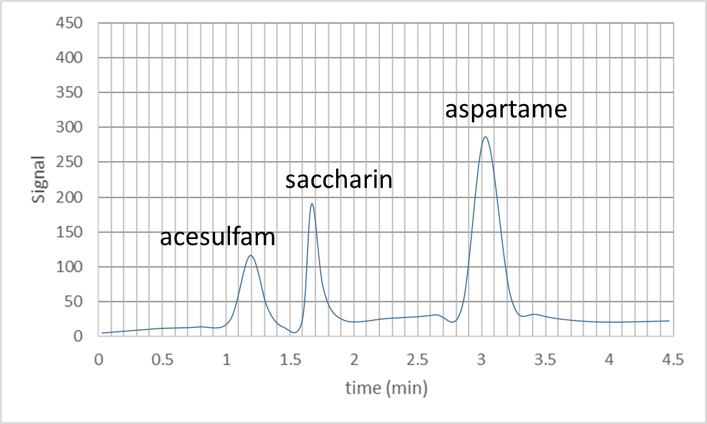

- From these results, the retention time for the different sweeteners are:
Sweetener | Retention time (min)
Aspartame
Saccharin
Acesulfam
1 mark

- To analyse the sweetener content of four different diet soft drinks, 50µL samples were injected into the HPLC column. Their chromatograms, with the corresponding area for each peak, are shown below
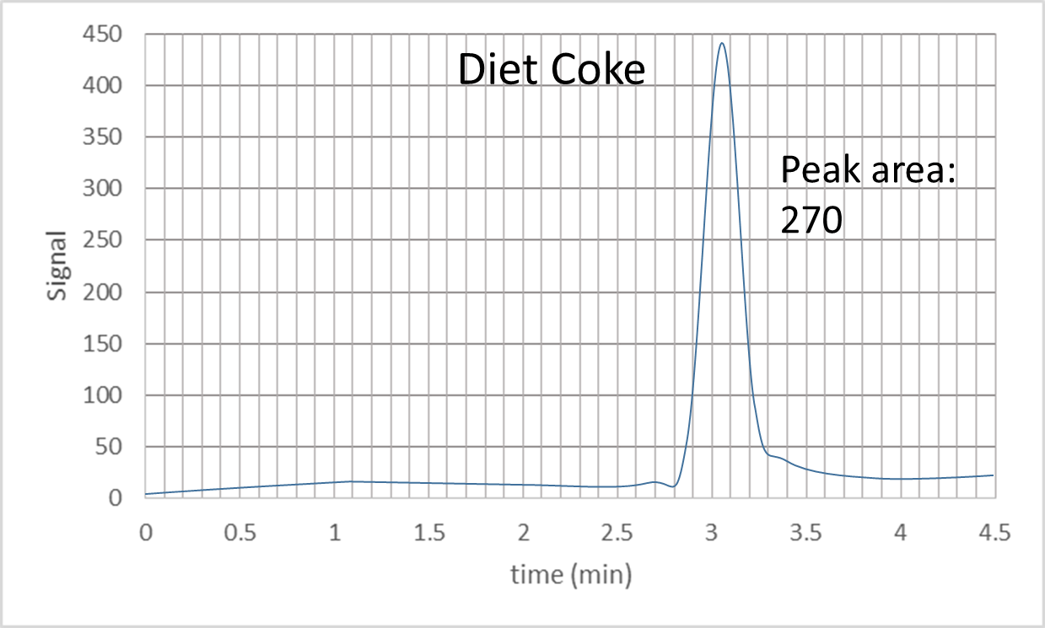 | 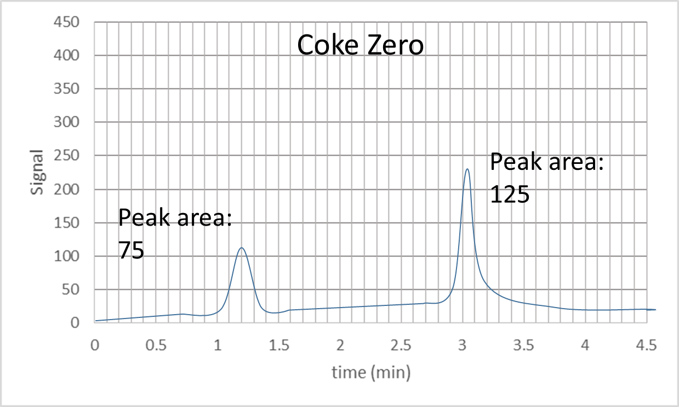
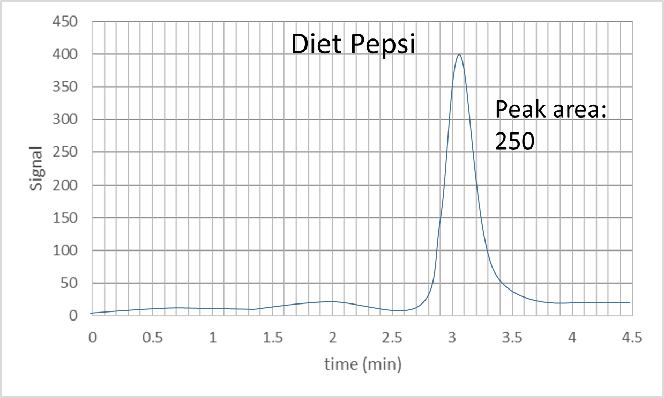 | 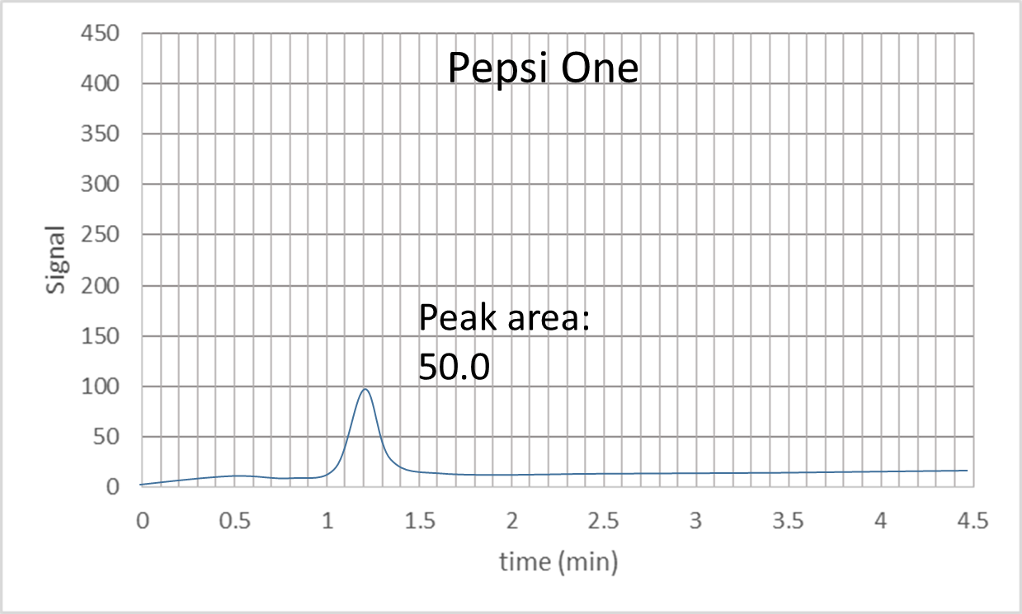

Based on these results, indicate with a tick the sweetener present in each soft drink
 | Sweetener
Soft Drink | Aspartame | Saccharin | Acesulfam
Diet Coke
Coke Zero
Diet Pepsi
Pepsi One
4 marks

- Five aspartame standard solutions containing 0.100 mg/mL, 0.250 mg/mL, 0.500 mg/mL and 0.750 mg/mL were prepared. 50µL of each sample was injected into the HPLC column. The chromatograms of the standard solutions each produced a single peak at a retention time of 3.05 minutes. The peak areas were measured and recorded in the table below.
Aspartame standard  (mg/mL) | Peak area
0.100 | 50.0
0.250 | 120
0.500 | 240
0.750 | 380

  - Using the results for the 4 standard solutions, construct a calibration graph including a straight line of best fit. Clearly label the axes and use appropriate units.

- Using the calibration graph and the chromatograms for each of the soft drinks calculate the amount of aspartame present in each of them:
Soft Drink | Aspartame (mg/mL)
Diet Coke
Coke Zero
Diet Pepsi
Pepsi One
- Taking into account that the acceptable daily intake of aspartame is 50.0 milligrams per kilogram (mg/kg), what is the maximum volume of Diet Coke that a person of 70.0 kg could drink per day?
2 + 2 + 2 = 6 marks

Question 4 (8 marks)
Nicotinamide adenine dinucleotide (NAD) is a coenzyme found in all living cells. It exists in two forms, an oxidized and a reduced form abbreviated as NAD⁺ and NADH, respectively. The concentration of NAD⁺ and NADH can be determined using UV-visible spectroscopy. The individual spectra of NAD⁺ and NADH are presented below.
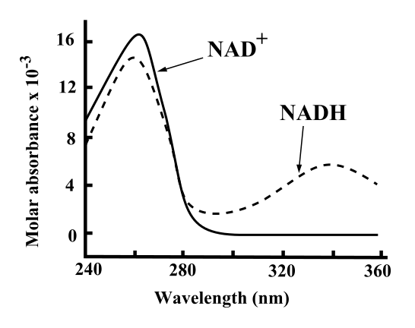

- Which wavelength could be used for absorbance measurements to determine the concentration of:

- A solution containing only NAD⁺

- A solution containing only NADH
1 + 1 = 2 marks

- The concentration of NADH can be determined using the following equation:

[NADH] = Absorption_{340nm} ÷ 6620 M⁻¹

The enzymatic reduction of NAD⁺ to NADH was followed in solution by monitoring the absorption at 340nm. The values obtained are shown in the table below:
Time | 0 min | 1 min | 2 min | 3 min | 4 min | 5 min
Absorption_{340nm} | 0.000 | 0.100 | 0.250 | 0.330 | 0.390 | 0.390

Taking into account that the initial concentration of NAD⁺ was 100 µM,
- What was the initial concentration of NADH?

- What was the final concentration of NADH after 5 min?

- How long did it take for half of the NAD⁺ to be reduced to NADH?
1 + 1 + 2 = 4 marks

- What would happen if instead of following the reaction at 340 nm the colorimeter was set up to measure absorbance at 260 nm? Could you follow the conversion of NAD⁺ into NADH? Explain.

2 marks

END OF QUESTION AND ANSWER BOOKLET

